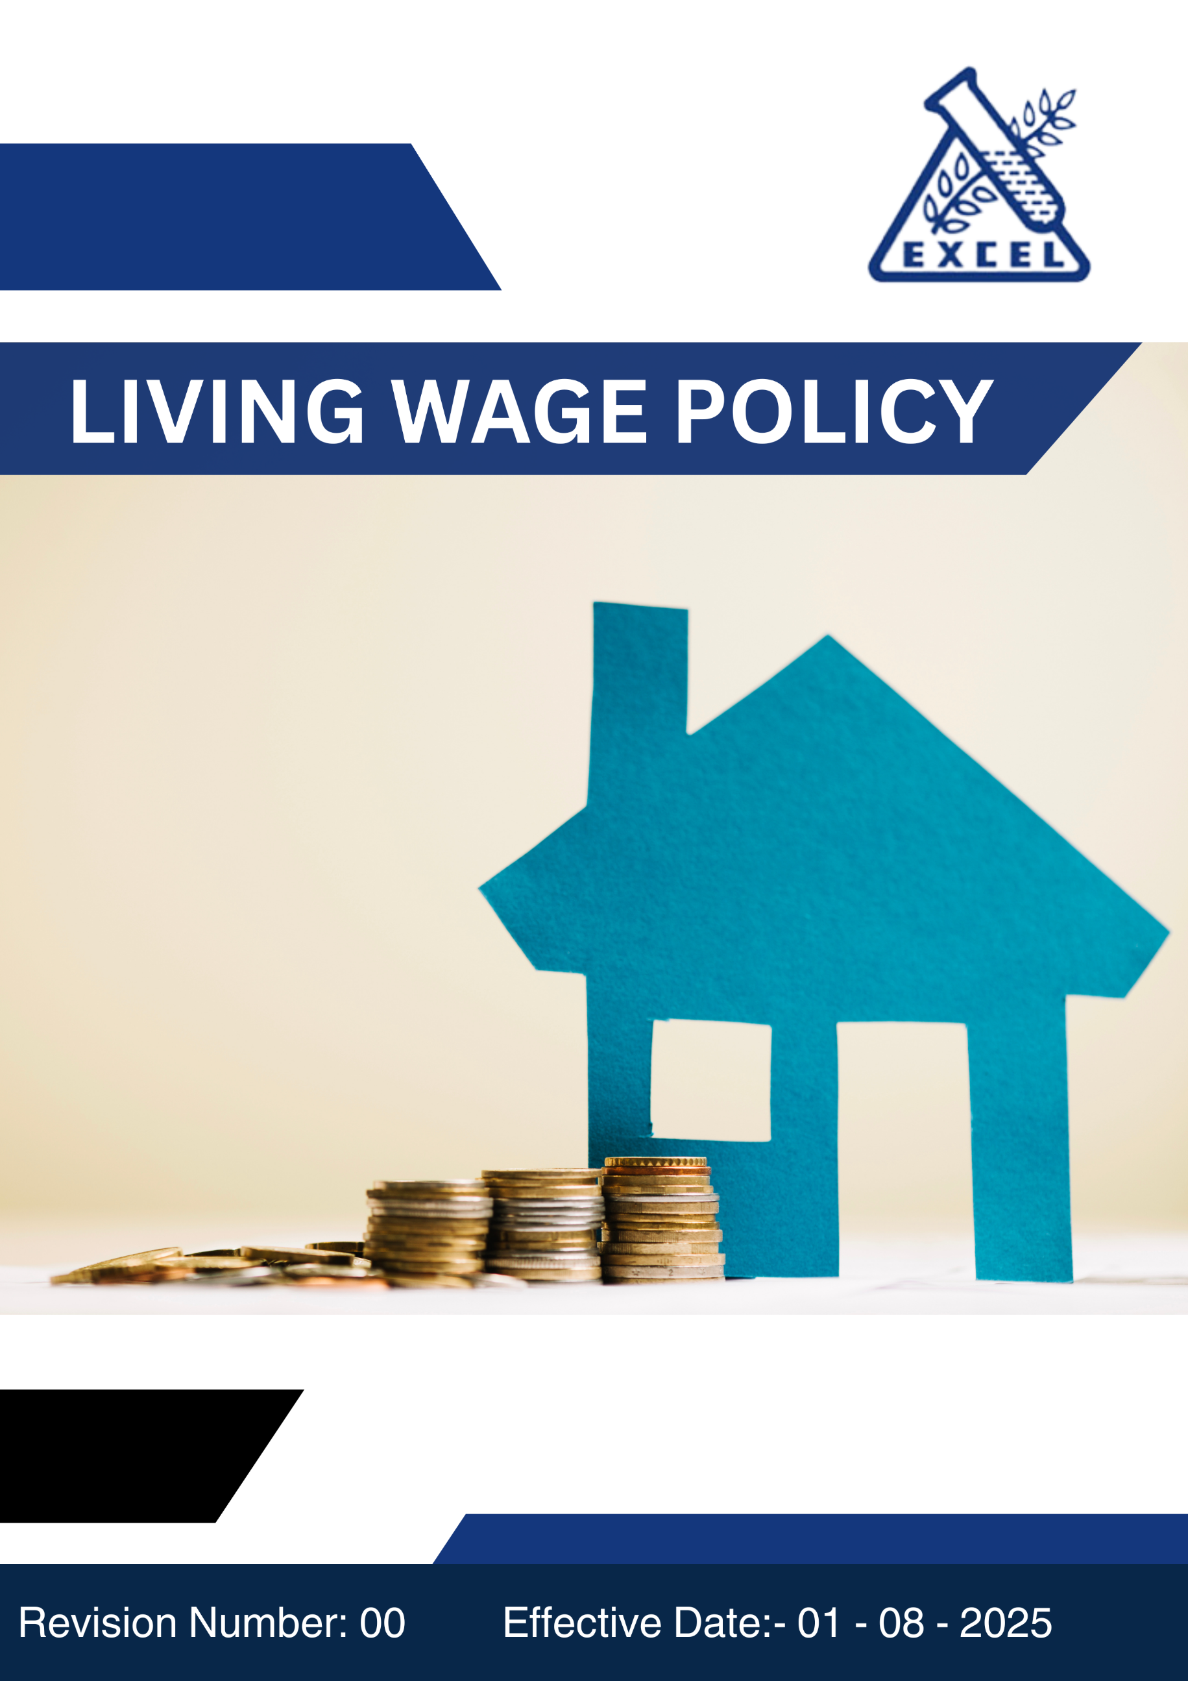
- OBJECTIVES:
Excel Industries Ltd. is committed to ensuring that all employees and contracted workers receive fair, equitable and living wages that meet or exceed legal and industry standards.
This policy aims to promote financial well-being, reduce inequality and strengthen social responsibility across all operations and supply chains.
It outlines the company’s approach to providing compensation that supports a decent standard of living, covering essential needs such as food, housing, healthcare, education and discretionary needs.

Through this policy, Excel Industries Limited ensures transparency, fairness, and accountability in wage practices, aligning with our sustainability principles and ethical business values to contribute to a more inclusive and equitable future for all.
- SCOPE:
This policy applies to all employees, contract workers and third-party labor engaged directly or indirectly by Excel Industries Limited across all operations. It also applies to all business units and functions within Excel Industries Limited, including procurement, manufacturing, research and development, logistics and corporate offices. It applies to all workmen working for the company including our own employees, contractors and their workmen working inside the premises, all stakeholders and external providers associated with the company.

This policy is applicable across all operating sites of Excel Industries Limited as listed below:
Sr. No. | Site Name | Location / Address
 | Corporate Head Office | 184/87, S.V. Road, Jogeshwari (W), Mumbai, Maharashtra 400102, India.
 | Roha Manufacturing Site | Plot No. 112, 20/1, OS-2, MIDC, Dhatav, Roha, Raigad, Maharashtra 402116, India.
 | Lote Manufacturing Site | D-9, MIDC, Lote Parshuram, Ratnagiri, Maharashtra 415722, India.
 | Visakhapatnam Manufacturing Site | Plot No. 15 & 15A, APSEZ, Atchutapuram, Vishakhapatnam, Andhra Pradesh, 531011, India
 | Excel Bioresources Limited,  Subsidiary | 184/87, S.V. Road, Jogeshwari (W), Mumbai, Maharashtra 400102, India.
 | Kamaljyot Investments Limited,  Subsidiary | 184/87, S.V. Road, Jogeshwari (W), Mumbai, Maharashtra 400102, India
 | Excel Rajkot C&D waste recycling Private Limited, Subsidiary | 184/87, S.V. Road, Jogeshwari (W), Mumbai, Maharashtra 400102, India

- POLICY STATEMENT :
(The Policy statement will be uploaded on website and will be printed for posters, cards etc for the purpose of communication).
Excel Industries Limited recognizes that fair pay is a foundation of human dignity, productivity, and sustainable development. The company is committed to ensuring that every employee and contract worker earns a living wage that provides for basic needs such as food, housing, healthcare, education, and savings while supporting an adequate standard of living for their families.
It is the Company’s endeavor to:
- Ensure that all employees and contract workers receive wages that meet or exceed statutory minimum wage and are benchmarked against living wage data.
- Conduct periodic wage assessments based on inflation, cost-of-living and independent benchmarks.
- Guarantee equal pay for work of equal value, free from gender, caste or other forms of discrimination.
- Maintain transparency in wage structures and ensure that no unauthorized deductions are made.
- Provide a confidential grievance redressal mechanism for employees to report wage-related concerns.
- Encourage suppliers, contractors and service providers to adopt living wage principles.
- Continually improve compensation practices through stakeholder feedback and periodic review.
This policy reaffirms Excel Industries Limited’s commitment to social equity, ethical labour practices, and sustainable growth across its value chain.

- QUALITATIVE TARGETS:
The Top Management of the company at Head Office and all sites are committed to provide full organizational support for achieving qualitative Living Wage targets, through the following directives:
Fair and Equitable Compensation:
- Ensure that all employees and contract workers are paid fair and equitable wages that meet or exceed statutory minimum wage requirements.
- Adopt compensation structures that reflect cost-of-living adjustments and maintain parity across roles and locations.
Transparency and Compliance:
- Maintain transparent wage determination and review mechanisms to ensure alignment with internal standards and external regulations.
- Regularly communicate wage-related policies and updates to all employees and worker representatives.
Capacity Building:
- Conduct periodic training and awareness sessions for HR teams, supervisors and management on fair wage practices and compliance obligations.
- Promote understanding among employees regarding wage structures, entitlements and grievance redressal mechanisms.
Continuous Improvement:
- Review wage structures annually to account for inflation, cost of living and industry benchmarks.
- Implement systems to regularly monitor wage compliance across all operational locations.

- Quantitative TARGETS:
We have set baseline year FY 2021-22 for the below KPI’s for the Living Wage Policy :

General Targets:
- Ensure 100% of direct employees and contract workers receive wages that meet or exceed living wage standards every year.
- Publicly disclose Excel Industries’ Living Wage Commitment and progress through the BRSR and Sustainability Report by 2034-35.
- Achieve 100% living wage implementation across all sites and supplier networks by 2034-35.

Wage and Cost-of-Living Adjustments:
- Implement annual wage revisions ensuring wages remain at least 10% above the national minimum wage by 2034-35.
- Ensure 100% wage adjustments reflect inflation and local cost-of-living variations by 2034-35.

Employee Welfare and Awareness:
- Provide living wage awareness training to 100% of HR staff, site managers and contractors annually by 2034-35.
- Establish grievance redressal mechanisms for wage-related concerns at 100% of sites by 2034-35.
- Achieve zero wage-related grievances unresolved beyond 30 days by 2034-35.

- Implementation and Accountability:
- Compliance: Ensure compliance with national wage laws, labor codes and internal compensation standards.
- Training: Conduct periodic training for HR, payroll and procurement staff on living wage implementation.
- Performance Monitoring: Set measurable wage improvement goals and track progress annually.
- Transparency: Maintain wage data, audit results and corrective action reports for internal and external review.
- Governance and Responsibilities:
- Managing Director and President & COO: Oversight of Living Wage Policy and Performance.
- Vice President Operations: Development and implementation of Living Wage strategies.
- Management Review Meeting (MRM) committee: Responsible for monthly review of the Policy at all sites to assess progress and make necessary amendments as required. Evaluates Living Wage performance metrics and KPIs. Ensures cross-functional coordination on Living Wage initiatives.
- Human Resources Department: Responsible for providing regular training, awareness programs, and updates related to wage laws, living wage benchmarks, and policy compliance.
- Finance Department: Ensure accurate, timely, and fair payment of wages.
- Procurement Department: Incorporate living wage requirements into all supplier and contractor evaluations.
- Site HR Heads: Ensure on-ground implementation and compliance at respective locations.
- All Employees: Adhere to the company’s compensation framework and report non-compliance through proper channels.
- Policy Review Mechanism:
- Monthly Review: The Policy will be reviewed monthly at all sites during the Management Review Meeting (MRM) to assess progress and make necessary amendments, if required.
- Performance Reporting: Regular reporting on wage and social performance to the MRM Committee will take place on a six monthly basis. The Board of Directors and stakeholders will review performance reporting through the Business Responsibility and Sustainability Report (BRSR) and Annual Sustainability Report (ASR) on a yearly basis.
- Stakeholder Engagement: Maintain continuous dialogue with employees, contractors, suppliers and other stakeholders to incorporate feedback and drive continual improvement in living wage and fair pay practices
- Failure of COMPLIANCE:
Employees who find any violation of the Living Wage Policy, its processes or any activity that may cause direct or indirect harm to business sustainability should address the same to their Head of Department (HOD) and further escalate it to the HR Head at site or at the Head Office.

Failure to comply with the provisions of this policy will be considered a violation of company policy and will be subject to disciplinary action, which may include warnings, suspension, or termination, depending on the severity of the non-compliance.
- Conclusion:
Excel Industries Limited reaffirms its commitment to ensuring that every individual contributing to the company’s success receives wages that reflect respect, dignity and fairness.
Through the implementation of this Living Wage Policy, Excel aims to promote social justice, economic well-being, and responsible business practices within and beyond its operations.

This policy will be reviewed Monthly for its adequacy and continued relevance to the organization’s business and sustainability objectives. It will be made available to employees, suppliers, contractors, and other stakeholders wherever required.

We will make this policy accessible to all employees, suppliers, customers, and stakeholders to demonstrate our unwavering commitment to sustainable growth and ethical excellence.
- POLICY DISTRIBUTION RECORD:
Sr. | Department | No. of copies
1 | All Departments: Mumbai Office. | ~10
2 | All Departments: Roha Site. | ~12
3 | All Departments: Lote Site. | ~12
4 | All Departments: Visakhapatnam Site. | ~10
NOTE: The Master Copy of this Policy document bears original signatures and a “MASTER COPY” stamp on each page, all controlled copies of this Policy are photocopies of the signed master copy, with a “CONTROLLED COPY” stamp. All other unsigned copies, printed copies, photocopies, or electronic copies of this Policy are uncontrolled copies.
- ACCOUNTABILITY (Document Preparation):
This policy will be prepared by AM HR, checked by GM Sustainability, reviewed by Vice President HR and President & COO. The policy will be approved and signed by the Managing Director of the company.

- REVISION HISTORY:
VERSION  NO. | DATE OF REVIEW | REASON FOR REVISION  (if revised). | APPROVED BY
00 | 01.08.2025 | New Document | R.A.Shroff

- EMPLOYEE ACKNOWLEDGEMENT:
I, the undersigned, acknowledge that I have read, understood, and agree to comply with the Living Wage Policy of Excel Industries Limited.
I am aware that this policy outlines the organization’s commitment to ensuring fair, equitable, and sustainable wage practices for all employees, contractors, and value chain partners.

I understand my individual responsibility to:
- Respect and uphold the company’s principles on fair compensation and living wage standards.
- Ensure compliance with all wage-related laws, internal procedures, and ethical compensation guidelines.
- Report any instance of wage disparity, underpayment, or non-compliance to my supervisor or the HR Department.
- Participate in required awareness and training sessions on fair pay and living wage practices.
- Support the company’s continuous improvement efforts toward achieving wage equity and social sustainability goals.

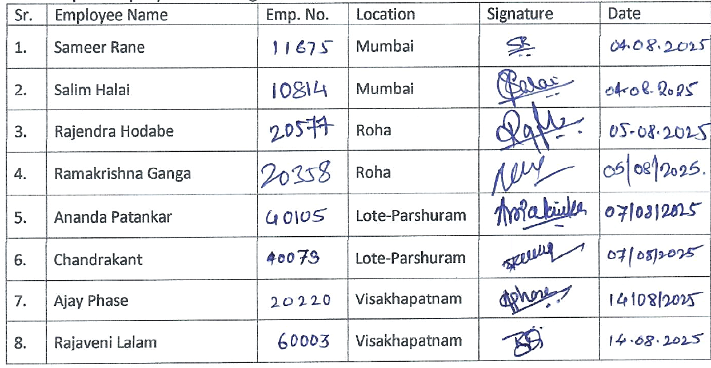
I also understand that failure to comply with the provisions of this policy may result in disciplinary action as per company rules and regulations.

